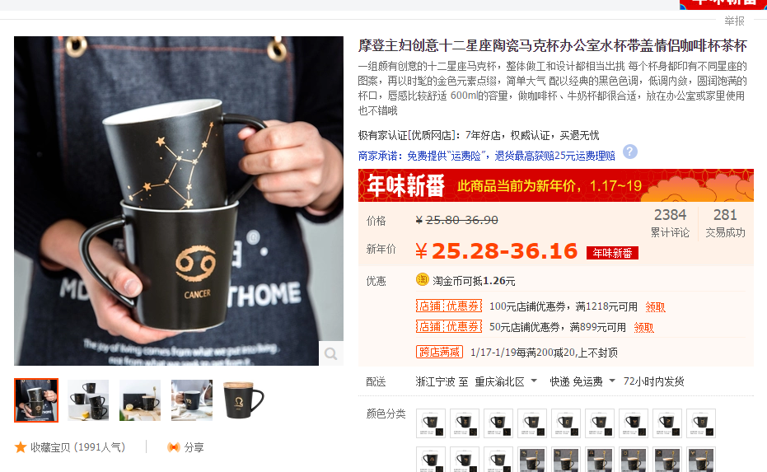

<https://item.taobao.com/item.htm?spm=a1z10.5-c-s.w4002-17431077637.61.39e2ada4bg7uTM&id=554725097873>

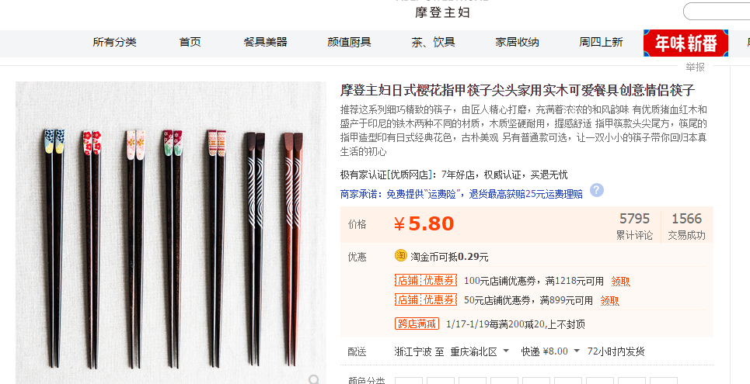

<https://item.taobao.com/item.htm?spm=a1z10.5-c-s.w4002-17431077637.27.16622c92KLsdKe&id=559073904705>

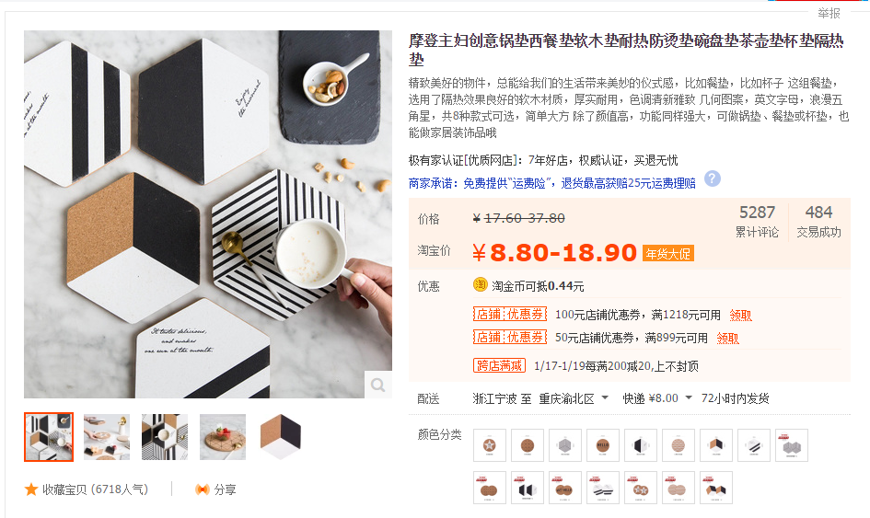

<https://item.taobao.com/item.htm?spm=a1z10.5-c-s.w4002-17431077637.28.29919b95PGVyP8&id=543192166508>

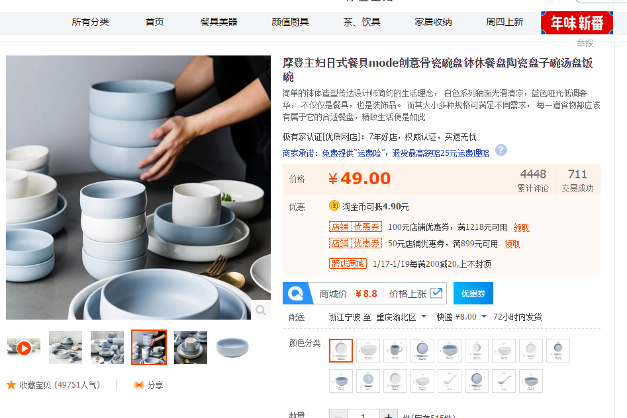

<https://item.taobao.com/item.htm?spm=a1z10.5-c-s.w4002-17431077637.55.29919b95PGVyP8&id=522893649612>

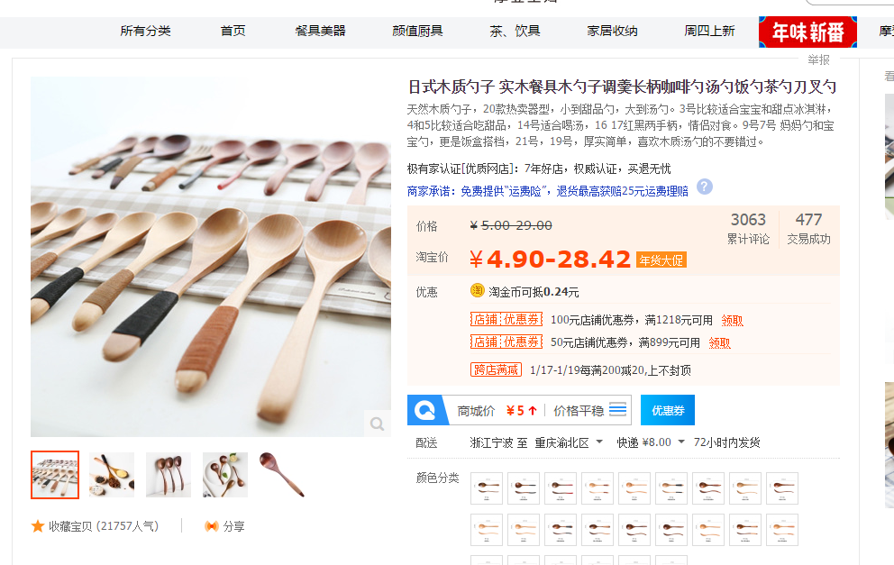

<https://item.taobao.com/item.htm?spm=a1z10.5-c-s.w4002-17431077637.37.1b139e5eJWQ8Lh&id=14973854000>

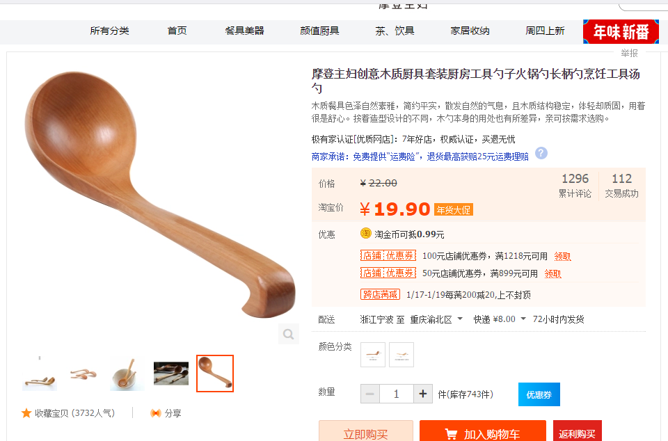

https://item.taobao.com/item.htm?spm=a1z10.5-c-s.w4002-17431077637.29.23bae133M3FlLO&id=38536245654

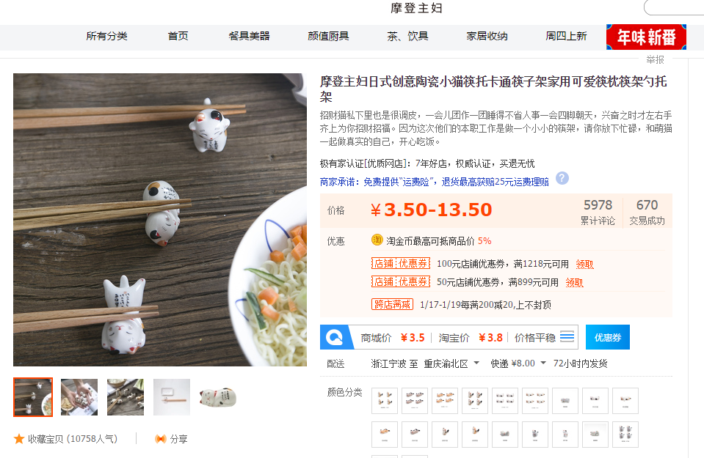

<https://item.taobao.com/item.htm?ft=t&spm=2013.1.0.0.2e7f46afHXzLa8&id=520282030529&scm=1007.12144.81309.42296_42224&pvid=69e73896-07c5-47fe-bb1f-d37f5bf05f79>

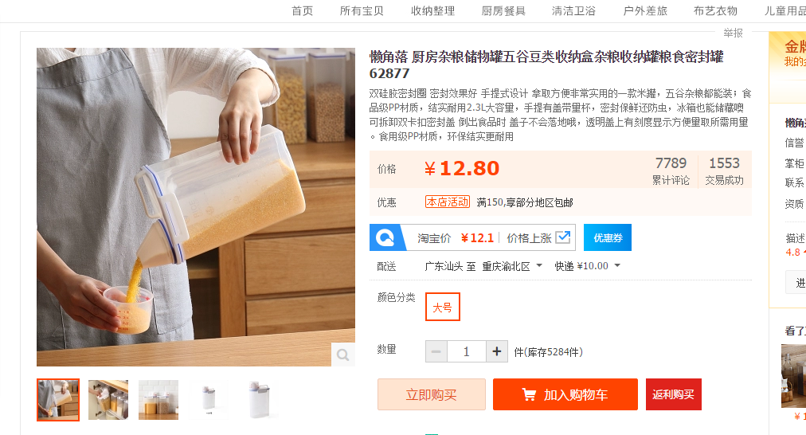

<https://item.taobao.com/item.htm?spm=a1z10.3-c-s.w4002-14437377231.85.8db7fe4GmSNcU&id=550338128880>

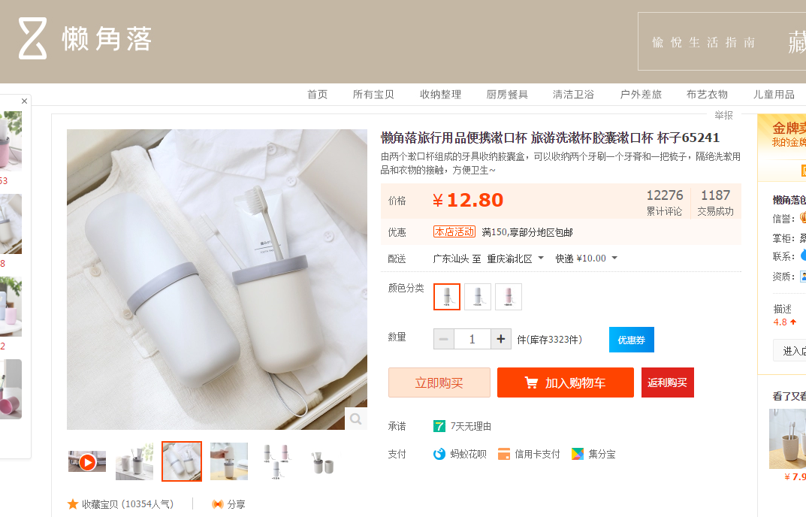

<https://item.taobao.com/item.htm?spm=a1z10.3-c-s.w4002-14437377231.50.b1299c9UBMPg1&id=541466621361>

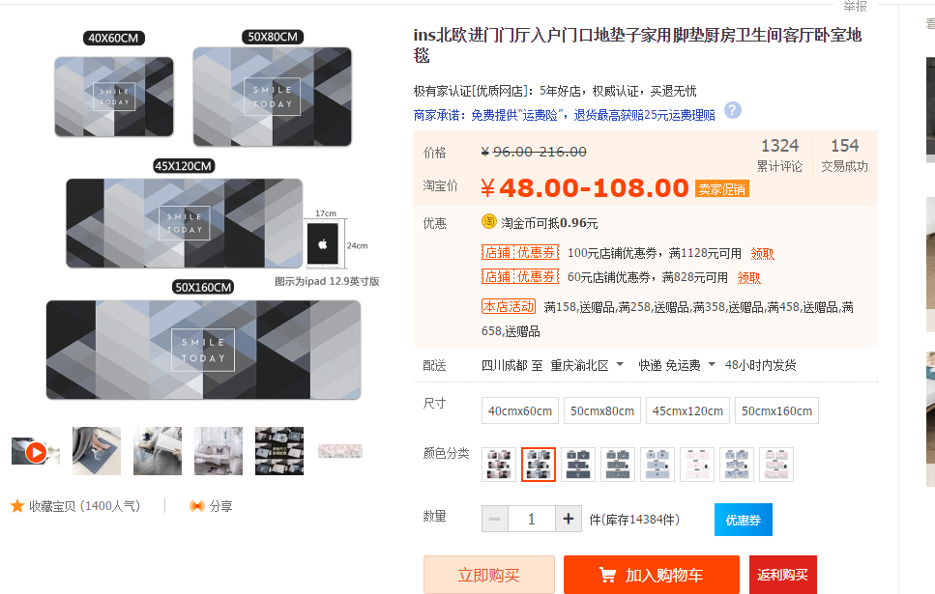

<https://item.taobao.com/item.htm?spm=a1z10.3-c-s.w4002-14532456498.76.3f7a1f86Qg9Lf1&id=559218770952>

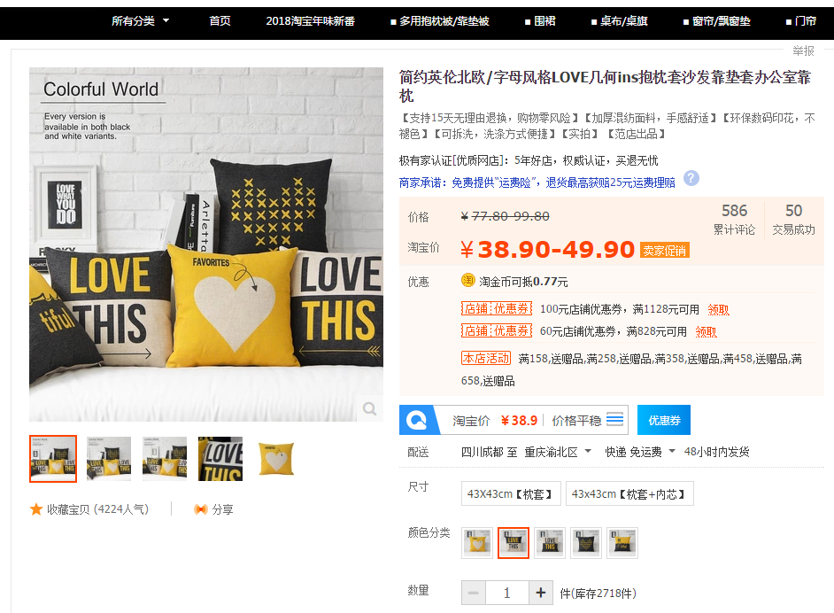

<https://item.taobao.com/item.htm?spm=a1z10.3-c-s.w4002-14532456498.14.38dd435atuMBnT&id=45811883283>

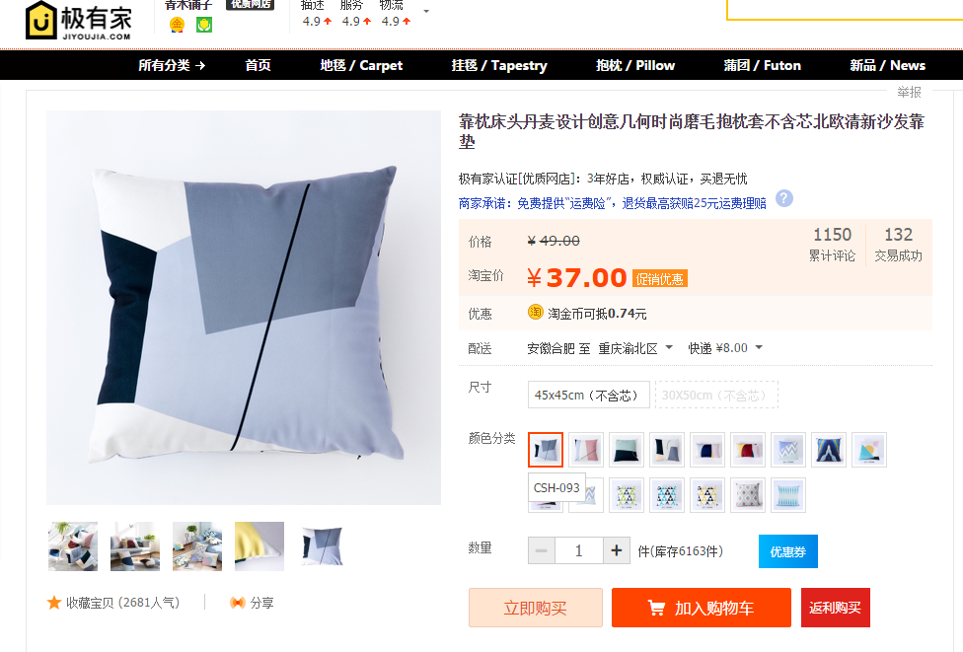

<https://item.taobao.com/item.htm?spm=a1z10.3-c-s.w4002-15203645518.47.227d4394NHsLAj&id=544448457696>

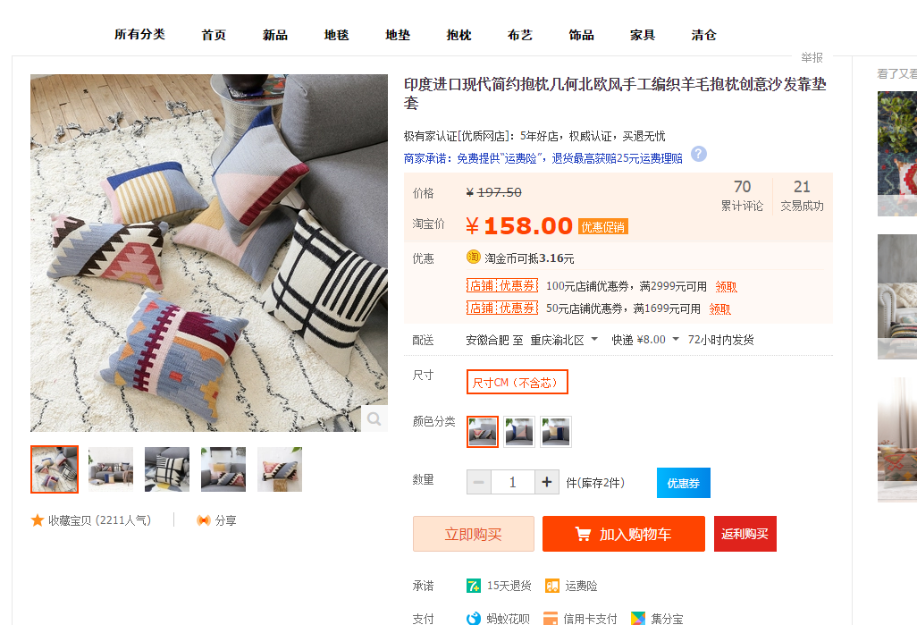

<https://item.taobao.com/item.htm?spm=a1z10.5-c-s.w4002-17131076039.53.70ef0614JUZAgO&id=534394047839>

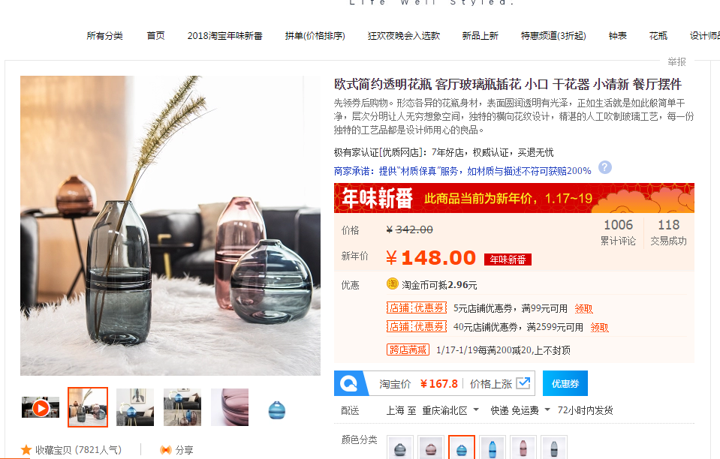

<https://item.taobao.com/item.htm?spm=a1z10.5-c-s.w4002-14904811159.18.267c4ee20oEfir&id=548140051690>

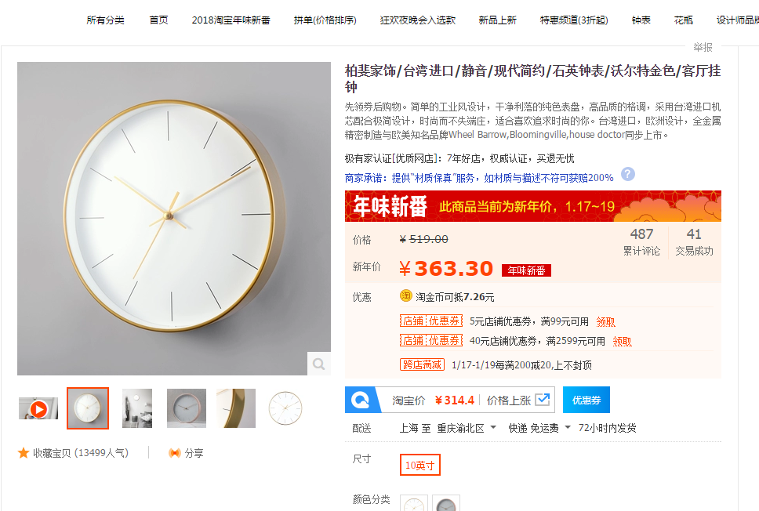

<https://bfjs.jiyoujia.com/category-1310907517.htm?spm=a1z10.5-c-s.w4002-14904811159.71.5fd22845mHBFfd&_ksTS=1516255761185_754&callback=jsonp755&mid=w-14904811159-0&wid=14904811159&path=%2Fcategory-1310907517.htm&search=y&catName=%D6%D3%B1%ED&scene=taobao_shop&catId=1310907517&pageNo=1#anchor>

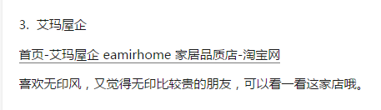

四件套

<https://eamirhome.jiyoujia.com/category-1118474376.htm?spm=a1z10.1-c-s.0.0.e03c63cPDZ0W3&search=y&parentCatId=1118474370&parentCatName=%B4%B2%C6%B7%CC%D7%BC%FE&catName=%B4%BF%C3%DE%BE%AB%CA%E1%C3%DE%CF%B5%C1%D0>

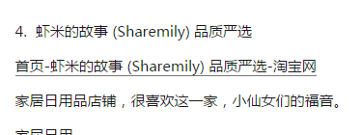

<https://zuoxuan64.jiyoujia.com/category-1102061630.htm?spm=a1z10.5-c-s.w5002-16709632583.6.2cde2b2dg1PRfH&search=y&catName=%B8%F7%D6%D6%CC%BA%D7%D3>

**2.诚艺家具旗舰店**

主要是卖一些家具配饰，质感不错又便宜。很适合刚做摆设，超喜欢那个铁皮小车的！非常有童年的感觉！！！很温馨！

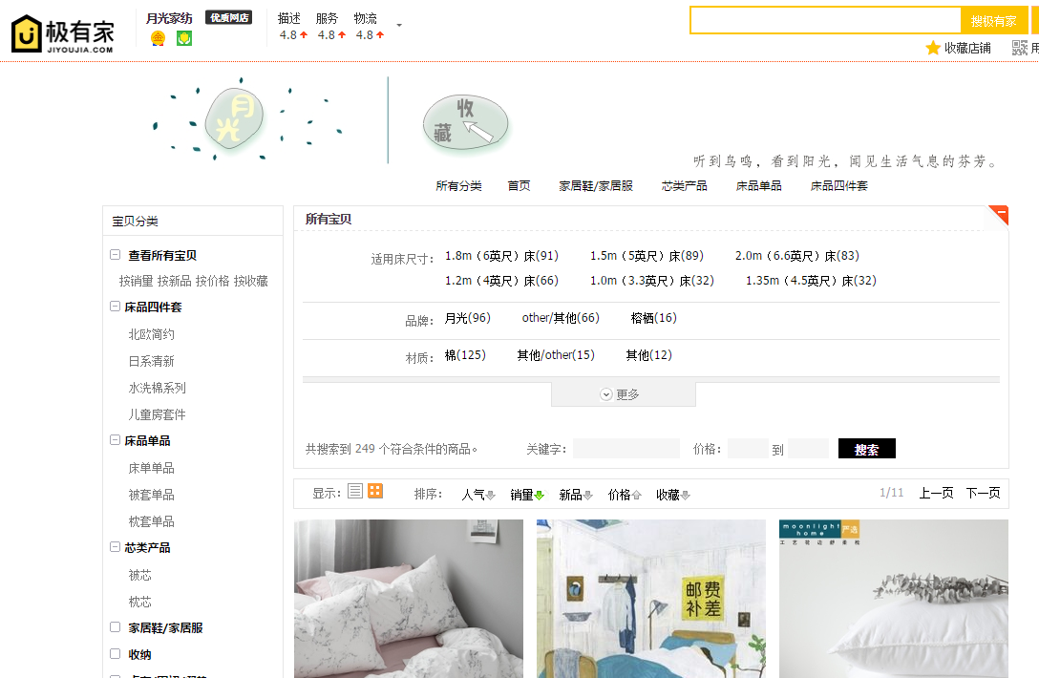

<https://yueguangjiafang.jiyoujia.com/search.htm?spm=a1z10.5-c-s.w5842-16616276201.3.21a29964uZEJck&search=y&orderType=hotsell_desc>

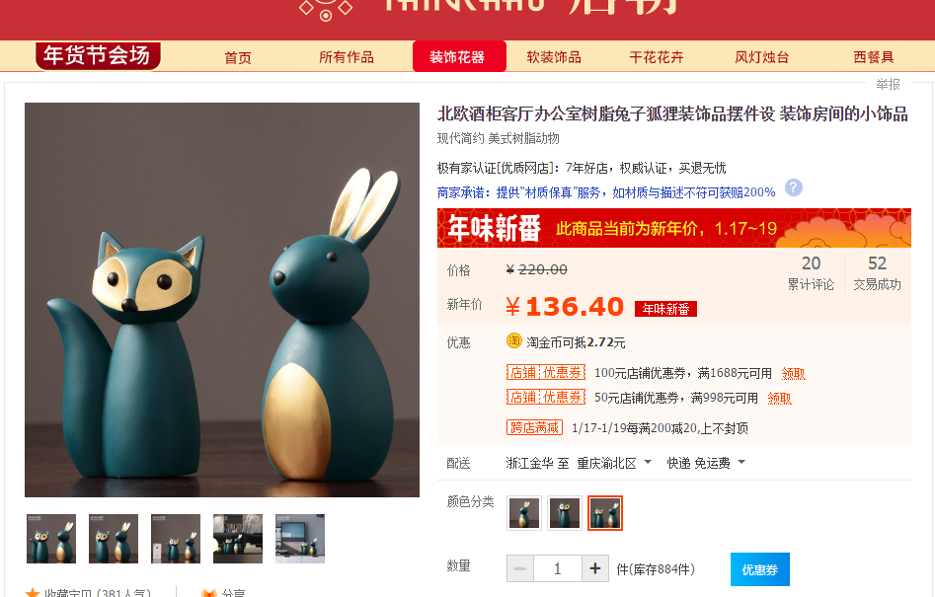

<https://item.taobao.com/item.htm?spm=a1z10.3-c-s.w4002-17531509056.55.1a6260947ckNmi&id=562590786962>

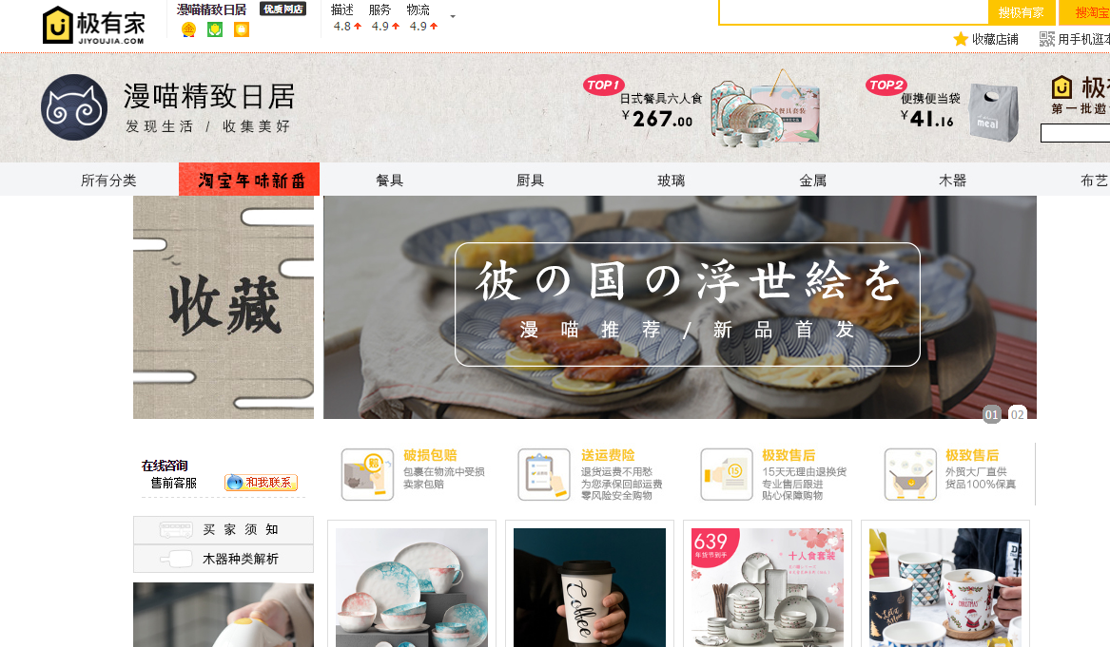

餐具

<https://man--miao.jiyoujia.com/category-804231324.htm?spm=a1z10.5-c-s.w4002-16611966633.101.22a783a6zFWoW8&_ksTS=1516331592501_274&callback=jsonp275&mid=w-16611966633-0&wid=16611966633&path=%2Fcategory-804231324.htm&search=y&parentCatId=804231323&parentCatName=%A6%F2%C3%FB%B3%C6%B7%D6%C0%E0%A6%F2&catName=%A1%B8%B2%CD%BE%DF%A1%B9%CD%EB&catId=804231324&pageNo=3#anchor>

**餐具类**

木上时光、日本南部铁器精品坊、不二家居、以艺术之铭、lototo、朵颐、梧桐树、不然、

yomerto、山舍、陶趣居、素宝、jasmine喵、熹山工房

**收纳类**

kens旗舰店、物生物、月亮女儿家居旗舰店、聚可爱、木上时光

**园艺类**

掬涵、伊斯特家居、沃施、左右的梦、庭院时光、四小时家居礼品、玖号院子

**家纺类**

壹源色、彩云原创、、我家有个植物园、七彩南方、布积木家居、雅艺尚品、松果木家居、致家家居、帘花记家居、mini more 、彼岸梦不落

**灯具类**

碧得森、mooore 、kc灯具、iwood、savia、自在灯饰、设计师的店、空明家、南灯记

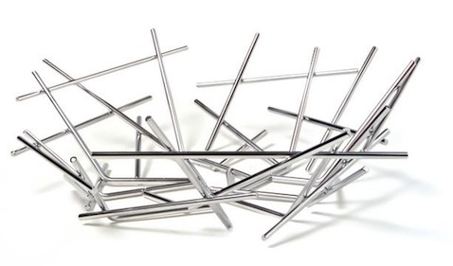

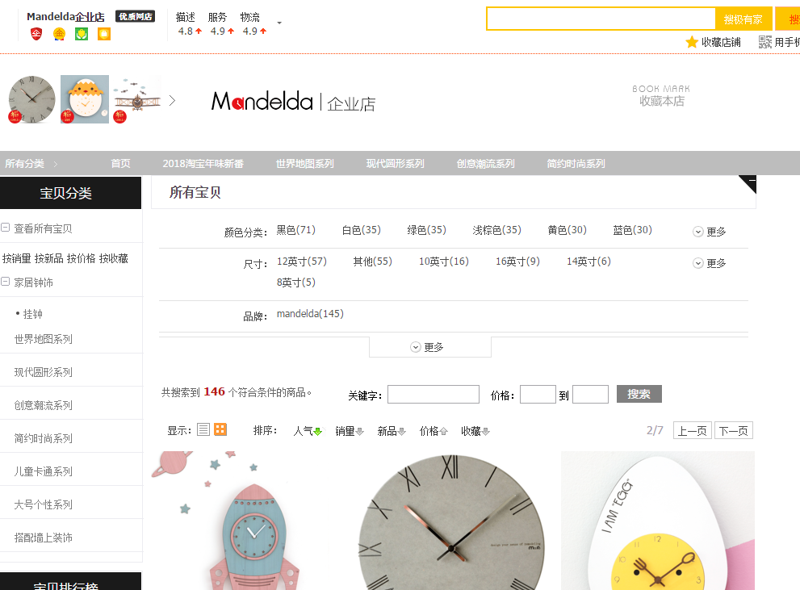

卖钟的

<https://jiyoujia149751060.jiyoujia.com/search.htm?spm=a1z10.3-c-s.w4002-15305512256.122.51d976cf47JaRq&_ksTS=1516336318614_160&callback=jsonp161&mid=w-15305512256-0&wid=15305512256&path=%2Fsearch.htm&search=y&pageNo=2#anchor>

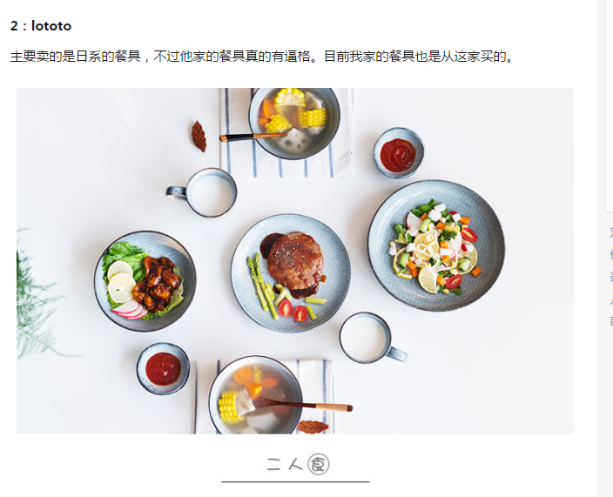

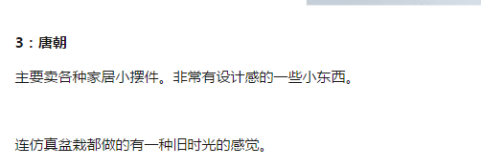

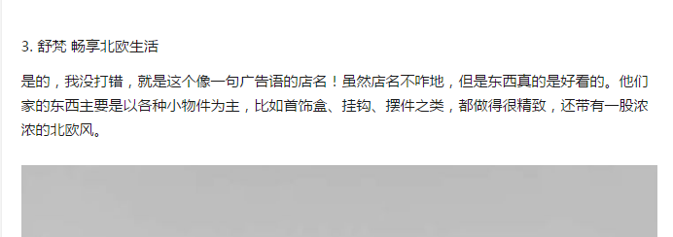

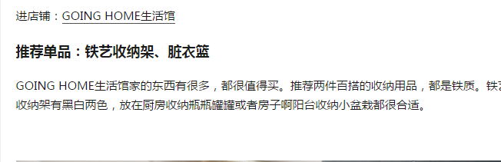

餐具 ：

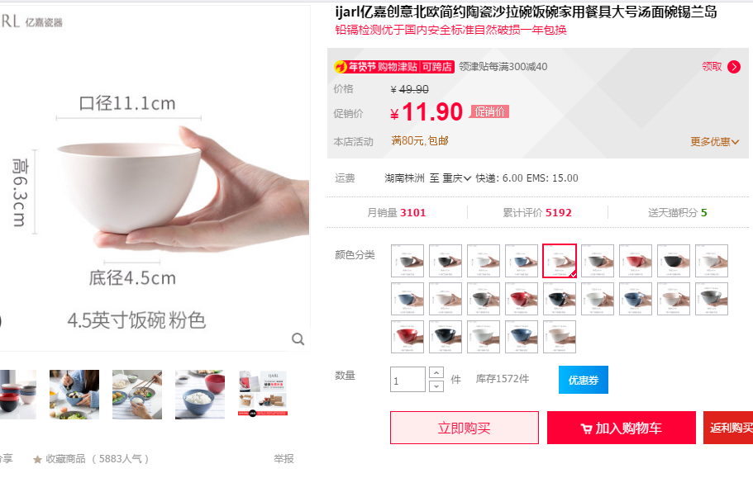

<https://detail.tmall.com/item.htm?spm=a220o.1000855.0.0.1ebf4e38982nF1&id=536548110509&skuId=3202769318152>

4.5英寸饭碗 5只 灰黑蓝粉白

6.25英寸面碗 2只 蓝粉

7英寸汤面碗 2只 黑红

8英寸面碗 2只 灰白

<https://detail.tmall.com/item.htm?spm=a220o.1000855.1998025129.3.f0ff4f1AW4wAP&abtest=_AB-LR32-PR32&pvid=f4e20786-67df-40be-95c2-75a3e5cba256&pos=3&abbucket=_AB-M32_B1&acm=03054.1003.1.2768562&id=531875118262&scm=1007.16862.95220.23864_0&skuId=3173255476556>

4.25英寸法海钵 2只 蓝灰

6英寸法海钵 2只 黑白

<https://detail.tmall.com/item.htm?spm=a220o.1000855.1998025129.2.1c4ef99aqjudC9&abtest=_AB-LR32-PR32&pvid=a52ca925-327a-41c3-935f-3edf5b29d277&pos=2&abbucket=_AB-M32_B1&acm=03054.1003.1.2768562&id=531224007752&scm=1007.16862.95220.23864_0>

8.5英寸(不规则) 平盘2只 灰蓝

9.3英寸（规则） 平盘2只 黑白

<https://detail.tmall.com/item.htm?spm=a1z10.4-b-s.w5003-16340172152.15.4d112a73oCoPsA&id=531656382322&scene=taobao_shop&skuId=3170176827697>

7.5英寸 双耳盘 3只 黑白灰

<https://detail.tmall.com/item.htm?spm=a220o.1000855.1998025129.7.4fd7fd5cNsg2g8&abtest=_AB-LR32-PR32&pvid=2dc9b2cd-8ce5-4d78-8e6f-d68de9ee00ce&pos=7&abbucket=_AB-M32_B1&acm=03054.1003.1.2768562&id=551222368971&scm=1007.16862.95220.23864_0&skuId=3531778190106>

勺子 5把 粉蓝白灰红

<https://detail.tmall.com/item.htm?spm=a220o.1000855.0.0.1ebf4e38982nF1&id=531585324561&skuId=3197950955788>

酱碟 5个 粉蓝白灰红

<https://detail.tmall.com/item.htm?spm=a220o.1000855.1998025129.3.68f59d6dMqIPoX&abtest=_AB-LR32-PR32&pvid=edb109e6-5251-4b93-bb37-2490bd4e6cb7&pos=3&abbucket=_AB-M32_B1&acm=03054.1003.1.2768562&id=551564222947&scm=1007.16862.95220.23864_0&skuId=3611965563082>

深汤碗 1个 蓝色